When we breathe, air travels through an arborized network of tubes to small sacs called ‘alveoli’, which are lined by specialized cells that perform the vital task of gas exchange. The alveoli consist of two main epithelial cell types including alveolar type II pneumocytes (AT2) that are stem cells and secrete surfactant, and thin alveolar type I pneumocytes (AT1) that interface with endothelial cells that line the surrounding capillaries to perform gas exchange [1]. During normal lung development, homeostasis, and regeneration, AT2 differentiate into AT1 to populate the alveolus. The mechanisms of AT2-to-AT1 transition are regarded as a crucial area of study, as it is often disrupted in disease. During injury-repair, several recent studies have found intermediate ‘transitional’ cell states between AT2 to AT1 that are not found normally in the lung. Interestingly, these transitional cells persist in the lungs with various forms of chronic lung disease [2-4]. The mechanisms that govern normal and abnormal AT2 to AT1 differentiation are still largely uncertain, as are those behind the persistence of transitional cells during disease. Understanding how the AT2-to-AT1 transition occurs under homeostasis is essential for uncovering pathogenic mechanisms of chronic lung disease, and therefore developing targeted treatments. While the molecular mechanisms controlling the AT2-to-AT1 transition are being intensely studied, how other cells within the alveolus may play a role has received little attention. Interrogations of the interactions between the alveolar endothelium and epithelium during injury-repair have been limited. The objective of this proposal is to assess the role of endothelial cell signaling and extracellular environment in AT2-to-AT1 transition.

Previous studies have found that normal capillary development is essential for alveolarization in the developing lung [5], and disruption of epithelial-endothelial contact is seen in various chronic lung diseases. However, the role of endothelial cells in epithelial identity and regeneration have not been thoroughly explored. Likewise, past research has established a role for extracellular matrix (ECM) during AT1 differentiation [6] and have characterized changes in ECM during lung disease [7], but have not interrogated the role of the neighboring endothelial basement membrane. Given the proximity of AT1 and endothelial cells [8], disruption in interactions seen in disease states, and preliminary data showing changes in AT2 phenotype upon co-culture with endothelial cells, I hypothesize that interactions between the alveolar endothelium and epithelium are critical for the normal regenerative response leading to AT1 differentiation and epithelial cell maturation.

**Aim 1: Investigate signaling interactions between human alveolar epithelium and endothelium and their effect on epithelial maturation and identity:** My preliminary data in co-culture organoids suggests that endothelial cell presence increases markers of AT2 maturity and enhances AT1 differentiation. Therefore, I hypothesize that signaling between AT2 and endothelial cells lead to AT2 maturation and AT1 differentiation. To test this hypothesis and elucidate the type of signaling taking place, I will perform co-culture experiments using fluorescently tagged endothelial cells and AT2 organoids with a dual fluorescent reporter for AT1. To display effects of both contact-dependent and paracrine (secreted) signaling, I will directly co-culture endothelial cells and AT2 organoids. To isolate the contribution of paracrine signaling, I will indirectly co-culture AT2 organoids on a transwell insert and endothelial cells in the wells below. To observe changes in interactions between cells and differentiation of AT1, I will perform live fluorescence imaging. To further assess changes in epithelial cell identity, I will examine gene expression via qPCR and protein expression and cell morphology via immunofluorescence staining.

**Aim 2: Interrogate the effects of changes in basement membrane composition on epithelial cell fate and maturation and alveolar organoid morphogenesis:** Endothelial and epithelial basement membrane vary in their composition, and neither is recapitulated by Matrigel. However, a recent study found that alveolar ECM contains many of the same components of vascular ECM [9].Given alveolar epithelial and endothelial cells are only separated by their own exceptionally thin basement membrane [8], the endothelial ECM may also play a role in AT2/AT1 fate and maturity. I hypothesize that proximity of the vascular basement membrane in the alveolar epithelial-endothelial contact regions influence epithelial identity and maintenance. To investigate this, I will first seed AT2 in an ECM array containing varying concentrations of epithelial ECM components, followed by imaging of AT1 reporter expression. I will then seed AT2 organoids in combinations of each of the ECM components shown relevant from the array, as well as vascular-associated ECM proteins, and in Matrigel. I will perform the same readout as described in Aim 1, with the addition of fibrotic and inflammatory markers to validate if the effects are mimicking a healthy or disease state.

This work will have a major impact on our understanding of the fundamental mechanisms by which the alveolus maintains homeostasis and reveal novel insights into how cell-cell interactions shape the alveolar niche and influence epithelial cell fate. This is essential to fully grasp normal development and how perturbations lead to aberrant or pathologic states. Additionally, this work will be a paradigm shift from a technological standpoint, as culturing AT1 cells has been exceptionally challenging or impossible, thus limiting research on this essential cell type in the lung and therefore drug development for chronic lung disease.

Research Plan

**Significance:** From our first breath to our last; the alveoli of our lungs (Figure 1) and their function of gas exchange are of critical importance for our survival and quality of life. One of the most common complications of pre-term birth, and a leading cause of mortality among preterm infants is respiratory distress syndrome [10, 11]. When infants are born prematurely, their lungs are not fully developed, with absent or immature alveoli and capillaries. Therefore, they often cannot breathe independently and require supplemental oxygen and mechanical ventilation. This can cause widespread damage to the lung, leading to a condition called bronchopulmonary dysplasia (BPD), as the immature alveolar niche is left to struggle to complete alveologenesis and repair the injury, despite the disruption of important developmental cues [11-14]. Consequently, the hallmarks of BPD include simplified alveoli with immature alveolar type II pneumocytes (AT2) that can’t yet produce surfactant, few alveolar type I pneumocytes (AT1) that are needed to perform gas exchange with endothelial cells lining capillaries, disorganized capillary beds, and impaired extracellular matrix (ECM) formation. The cycle of damage and repair the alveoli undergo in BPD patients is often associated with other complications such as emphysema, pulmonary hypertension, and fibrosis [11-14].

**Figure 1:** **Structure of 2D cross-section of normal alveoli** [1]. **A)** Aim 1. **B)** Aim 2. AT2 = alveolar type II pneumocyte (pink). AT1 = alveolar type I pneumocyte (green). EC = endothelial cell (blue). FB = fibroblast (orange). O2 = oxygen. CO2 = carbon dioxide

While pediatric lung diseases impacting the alveoli tend to stem from injury to underdeveloped lungs in premature infants, those in adults are often the result of a combination of predisposing factors and environmental exposures. Idiopathic pulmonary fibrosis (IPF) involves alveolar remodeling as the result of repeated cycles of damage and aberrant repair. Its hallmarks include loss of AT1 populations, proliferation of AT2, accumulation of ‘stuck’ transitional AT1, proliferation of apoptosis-resistant fibroblasts that secrete pro-fibrotic growth factors and contribute to excessive ECM deposition, and disruption of the alveolar-capillary barrier [2, 15, 16]. These changes lead to increasing alveolar rigidity and progressively impaired ability to breathe. Emphysema is a type of chronic obstructive pulmonary disease (COPD) that involves the destruction of the alveolar walls, trapping air inside and impairing their ability to perform gas exchange [17]. While there are numerous causes of emphysema, they all involve damage to the alveolar epithelium, resulting in loss of AT1, impaired AT2 regenerative ability, ECM remodeling, and dysfunctional capillary endothelial cells [18-20].

Both infant and adult lung diseases have long-term impacts on quality of life and are among the leading causes of death for the age groups they affect [11, 13, 16, 17]. Each of their mechanisms are poorly understood, resulting in primarily symptomatic treatments and a lack of targeted therapeutics to treat the underlying pathogenic processes. While BPD manifests in premature infants and IPF and COPD afflict adults, they share many of the same pathologic hallmarks—notably abnormal AT1 development or regeneration [2, 11-16, 18]. Accordingly, the molecular mechanisms of AT2-to-AT1 differentiation have become a topic of increasing study; however, the source of the cues governing this transition remains largely uncertain.

While aberrant AT1 populations in chronic lung disease have rightfully garnered much attention, BPD, IPF, and COPD also share abnormal ECM remodeling and disruption of the alveolar-capillary barrier, the latter of which has been the subject of far less study. These features of chronic lung disease have largely been studied in isolation, rather than with respect to how they may be influencing epithelial identity. During normal human lung development, alveolarization and capillary development occur concurrently [1, 8, 21-23], and disruption of vascular development has been suggested to impair alveolar development [5, 13, 14, 24]. This observation led to the development of the ‘vascular hypothesis’ of BPD, which posits that the alveolar development in BPD is impaired by dysmorphic vascular growth [25, 26]. Vascular remodeling and endothelial cell death have also been observed in IPF and COPD, but capillary endothelial cells have not been examined as a potential influence on AT2-to-AT1 transition [26, 27]. These established changes in vasculature across development and in disease states that involve AT2/AT1 dysfunction, combined with my preliminary data revealing changes in AT2 and AT1 gene expression upon co-culture with endothelial cells (Figure 2), lead me to hypothesize that interactions between capillary endothelial cells and alveolar epithelial cells are essential for normal AT1 differentiation and epithelial cell maturation (Figure 1A).

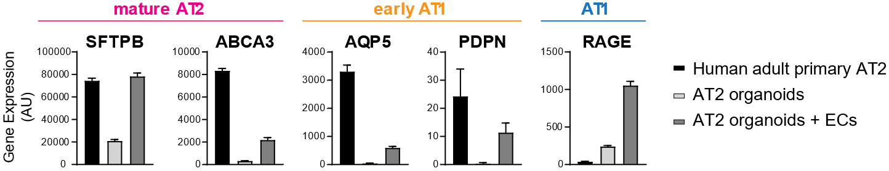

**Figure 2: Co-culture of AT2 organoids with endothelial cells increases expression of mature AT2-, early AT1-, and AT1-associated genes.** Gene expression via RT-qPCR normalized to 18s and ECAD of mature AT2 markers (SFTPB and ABCA3), early AT1 markers (AQP5 and PDPN), and AT1 marker (RAGE) for primary human adult AT2 (black), AT2 organoids (light gray), and AT2 organoids co-cultured with endothelial cells (ECs) (dark grey).

As previously discussed, another common feature shared by lung diseases such as BPD, IPF, and COPD is ECM remodeling. In BPD, this involves disorganization of existing ECM by mechanical ventilation and a lack of normal ECM deposition needed as a scaffold for further alveolar formation [13, 14, 28]. In IPF, there is an excess of fibrous ECM proteins produced by fibroblasts that increases the distance and resistance between alveolar epithelial cells and capillary endothelial cells [16, 31]. In COPD, alterations in ECM composition and increased turnover of ECM molecules contribute to airway remodeling [7, 20]. Previous studies have shown a role for ECM in AT2 phenotype and AT1 differentiation but have not interrogated the role of the neighboring endothelial basement membrane [6, 30, 31]. Given the established role of ECM in epithelial cell fate, and the spatial proximity of endothelial and epithelial basement membranes that is disrupted in disease states, I hypothesize that ECM components of the vascular basement membrane encourage AT1 identity and maintenance (Figure 1B).

Collectively, this proposal will establish the role of endothelial signaling and environment on alveolar epithelial cell fate decisions. Improving our understanding of normal and aberrant interactions between alveolar epithelium and endothelium and how they may disrupt homeostatic processes to lead to disease states will further the state of our knowledge on lung diseases that impact the quality and length of life of millions of Americans. This work will also provide valuable insight into regenerative mechanisms that could be leveraged to enable the development of new therapeutics for chronic lung disease with the potential to decrease disease burden and mortality and improve quality of life.

**Innovation:** ***Conceptually***, the proposed experiments will address the question of mechanisms governing AT2-to-AT1 transition from a new perspective that considers vascular structure and ECM not as orthogonal features of lung homeostasis, but as underlying mechanisms of epithelial cell behavior and regenerative ability. This framework ties together observations across various chronic lung diseases over the human lifespan with what is currently known about normal lung regeneration to address a fundamental question in lung biology and disease.

***Technically***, this work would lead to the novel establishment of an organoid model of the alveolus with phenotypically relevant AT1. Historically, isolating and culturing AT1 cells has been exceptionally challenging or impossible, limiting the field’s research on this cell type that is essential for the primary function of the lung: gas exchange. Organoid models of the alveolus currently used for lung research and drug development primarily consist of AT2 that do not differentiate into AT1 in organoids as they would in vivo. While AT2 are incredibly important, they lack the gas exchange functionality of AT1, limiting the insight provided by in vitro organoid studies and drug development projects. Additionally, this project would establish a co-culture alveolar epithelial-endothelial organoid model that could be utilized for alveolar-capillary barrier studies.

**Aim 1: Investigate signaling interactions between human alveolar epithelium and endothelium and their effect on epithelial maturation and identity.**

**Rationale:** The endothelial cells that make up the microcapillaries surrounding the alveoli arise in conjunction with AT1 during human lung development [1, 8, 21-23]. Disruption of microcapillary development has been shown to impair alveologenesis [5, 13, 14, 24], and several lung diseases in adulthood characterized by a paucity of AT1 or accumulation of aberrant transitional cells also involve disruption or destruction of the microvascular endothelium [25-27]. However, the role of endothelial cells in alveolar epithelial maintenance and AT2 to AT1 cell differentiation has not been elucidated. My preliminary AT2 organoid and endothelial cell co-culture data have shown an increase in markers of AT2 cell maturity and AT1 cell identity (Figure 2). The objective of this aim is to investigate whether contact-dependent or secreted signaling taking place between AT2 cells and endothelial cells act as a cue for AT2 differentiation to AT1 (Figure 1A). To accomplish this goal, I will test the working hypothesis that signaling between AT2 cells and endothelial cells lead to AT2 cell maturation and differentiation to AT1. The experiments described in this aim will confirm preliminary findings that endothelial cells influence AT2/AT1 cell fate and determine the contributions of 1) contact-dependent signaling and 2) paracrine (secreted) signaling in these interactions (Figure 3).

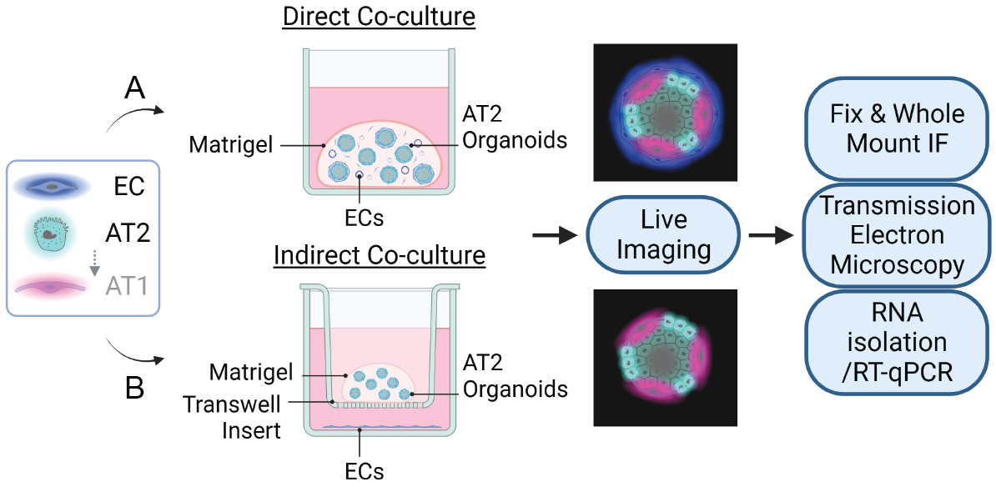

**Figure 3:** **Experiment plan for Aim 1**. **A)** Aim 1.1: Direct co-culture of AT2 organoids (green) and endothelial cells (ECs, blue). **B)** Aim 1.2: Indirect co-culture of AT2 organoids and ECs on transwell inserts. Alveolar type I pneumocytes (AT1, green). Created with BioRender.com

**Experimental Approach:** To determine the effects of contact dependent and paracrine endothelial cell signaling on epithelial cell fate, I will perform co-culture organoid experiments. These will utilize human induced pluripotent stem cell (iPSC)-derived AT2 with a dual fluorescent reporter for AT1 and fluorescently labeled human reprogrammed vascular endothelial cells (RVECs) [32].

***Preparation of fluorescently labeled AT2 organoids and RVECs:*** To generate dual reporter AT2 organoids, I will direct an established and validated NKX2.1-GFP and RAGE-tdTomato iPSC cell line [33] through a 30-day AT2 organoid differentiation protocol (Figure 4) [34]. All cells that are derived from a lung epithelial lineage, including AT1 and AT2, express NKX2.1 and therefore will be GFP+ and only AT1 express RAGE and will be tdTomato+. I will perform RT-qPCR and flow cytometry for AT2 markers to ensure the success of the differentiation. I will also treat them with LATS-in-1, which has recently been shown to induce differentiation of AT2 to AT1, to confirm their potential to differentiate to AT1 [33]. Likewise, a condition treated with LATS-in-1 will be included as a positive control for AT2 differentiation to AT1 for each experiment in this research plan. The AT2 organoids can then be passaged and maintained in culture for use in experiments in the following aims. To fluorescently label RVECs, I will utilize Invitrogen’s CellTracker Blue CMAC Dye, which remains in the cells for around six generations (Figure 5).

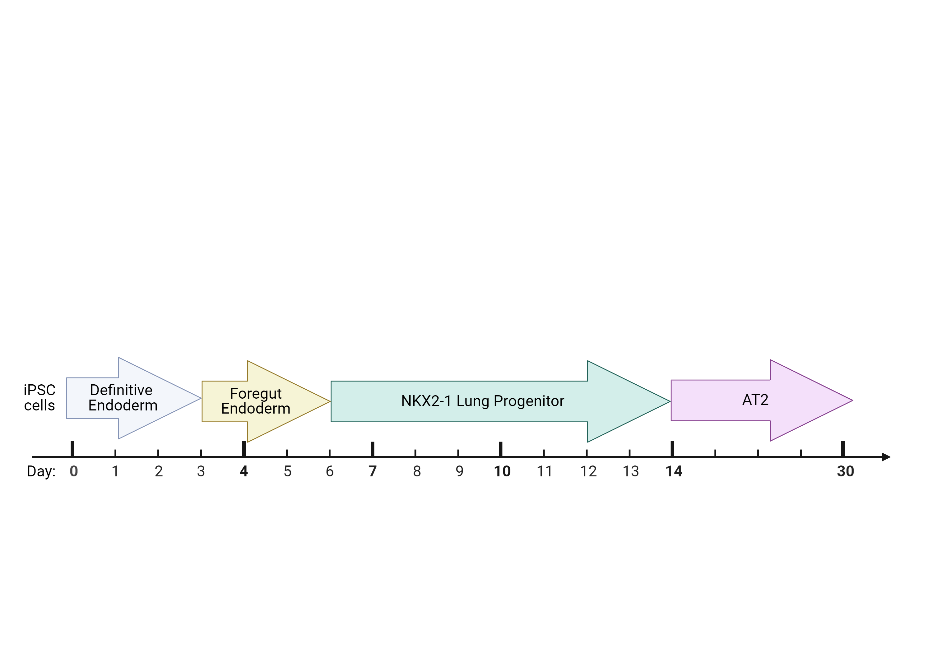

**Figure 4**: **Differentiation scheme of iPSCs to AT2 cells** [32]. Created with BioRender.com

**Figure 5:** **Live imaging using CellTracker dyes**. AT2 organoids labeled with CellTracker Red (pink) co-cultured with endothelial cells labeled with CellTracker Green (green).

***1.1 Direct co-culture of AT2 organoids and RVECs:*** I will examine the effects of contact-dependent signaling using a direct co-culture organoid model. To do so, I will needle-passage the dual reporter AT2 organoids, then mix them with fluorescently labeled RVECs. The co-cultures will then be seeded in Matrigel extracellular matrix domes to provide a three-dimensional (3D) growth environment (Figure 3A). These will be co-cultured for 7 days, based on RVEC vessel formation time and duration of gel stability. To add temporal resolution to the experiment by observing physical interactions between AT2 cells and RVECs and AT1 reporter expression over time in culture, I will perform time-lapse live fluorescence confocal microscopy utilizing each cell type’s unique fluorescent label. At 7 days of co-culture, I will remove organoids from fibrin and Matrigel and fix or lyse the intact organoid pellets. Transmission electron microscopy will be used to confirm the absence of lamellar bodies, surfactant-producing organelles specific to AT2 [1], in cells with AT1 reporter expression or elongated morphology. To visualize the overall organoid structure, changes in cell morphology, and cell-specific protein expression, fixed organoids will be either paraffin-processed and embedded for sectioning or processed for whole-mount immunofluorescence staining (IF) and confocal imaging. To characterize changes in gene expression corresponding to AT2, AT1, transitional cells, and endothelial cells upon co-culture, RT-qPCR will be performed on RNA from the lysed organoids and compared to each population alone and primary adult human AT1 and AT2 as controls.

***1.2 Indirect co-culture of AT2 organoids and RVECs:*** Because the direct co-culture model will inherently display effects of both contact-dependent and secreted signaling, I will isolate the effects of paracrine signaling using an indirect co-culture model. To accomplish this with minimal changes to the culture method, I will passage dual reporter AT2 organoids as previously described, then seed them without RVECs in Matrigel domes on top of a permeable trans-well membrane (Figure 3B). RVECs will then be seeded on the bottom of the wells, allowing them to secrete factors into the media that can diffuse across the membrane and Matrigel, but not allowing the RVECs to make direct contact with AT2 cells. I will then use the same experimental measures described in ***1.1***.

**Expected Outcomes:** Preliminary data suggests that co-culture of endothelial cells with AT2 cells results in increased expression of genes corresponding to AT2 maturity and AT1 fate. I anticipate that this may be due to a combination of contact-dependent and paracrine signaling between AT2 cells and endothelial cells. Therefore, I expect that expression of genes corresponding to AT2 maturity and AT1 identity will increase in both co-culture models but may increase more substantially in the direct co-culture model, and those corresponding to transitional cells will be decrease or remain unchanged. I anticipate similar findings in protein expression via IF. I expect that elongated AT1-like cells will no longer contain lamellar bodies indicative of AT2 identity. Additionally, during the time-lapse live imaging, I expect to see an association between localization of endothelial cells and subsequent AT1 reporter expression in neighboring former AT2. I also expect to see a greater presence of cells exhibiting thin, elongated AT1-like morphology in the direct co-culture model. If I indeed see the predicted differentiation of AT2 to AT1 upon endothelial cell co-culture, I also expect to see a change in overall organoid structure, which will become more cystic with thinner AT1 comprising the epithelial walls of the organoids.

**Pitfalls & Alternative Approaches:** ***1)*** One limitation of this experimental design is that NKX2.1 expression is not AT2-specific [1], limiting the ease of verifying the identity of the non-AT1 epithelial cell population. Given this can be confirmed by IF following collection, this is of most concern with regards to ensuring an AT2 starting cell type. As described previously, after differentiating the dual reporter iPSCs to AT2 cells, I intend to confirm the success of the AT2 differentiation using flow cytometry and RT-qPCR. However, if the expected outcomes are not seen, one possibility is that the AT2 cells de-differentiated over time while maintaining the culture, resulting in a cell type that cannot readily differentiate into AT1. The identity of the starting AT2 population can be confirmed by flow cytometry of AT2 from the same passage for the surface protein, HTII-280 [35], and subsequent sorting of AT2 using FACS prior to co-culture if necessary. Alternatively, a dual reporter iPSC line for AT2- and AT1-specific markers could be developed but doing so would potentially delay the proposed research timeline. ***2)*** If the expected increases in AT2 maturity and differentiation to AT1 are not observed or are not of a statistically significant magnitude, it is also possible that 7 days will not be long enough to induce changes in AT2 phenotype and AT1 differentiation. To address this possibility, I will repeat the experiments with longer co-cultures of 14 and 21 days. If there are issues with loss of Matrigel or fibrin gel structure with extended co-cultures, I will carefully remove organoids from the initial gel and re-seed in fresh domes of the corresponding gel. ***3)*** Another potential problem is that CellTracker has been reported to have minor transfer to neighboring cells and effects on cell proliferation and differentiation [36, 37]. If these issues present, I will develop a fluorescent RVEC cell line. If issues arise with developing this cell line, I could alternatively forgo live fluorescent labeling of RVECs and rely on IF staining to characterize their spatial localization with AT2/AT1 at the expense of temporal information.

**Aim 2: Interrogate the effects of changes in basement membrane composition on epithelial cell fate and maturation and alveolar organoid morphogenesis.**

**Rationale:** Extracellular Matrix (ECM) composition has been previously reported to influence alveolar epithelial cell fate [27-29], but the specific makeup of the alveolar ECM compared to that of the rest of the lung and vasculature was not characterized until recently [38]. The study found that alveolar ECM contains many of the same components as vascular (endothelial) ECM, neither of which is recapitulated by Matrigel, which is derived from mouse tumor cells. It is possible that these findings were influenced by the close proximity of the alveolar epithelial basement membrane to the capillary endothelial basement membrane, which would make it difficult to isolate one without the other. Another recent study building upon those findings derived a hydrogel from decellularized human lung enriched for alveolar regions and found that culturing AT2 organoids in this hydrogel resulted in elongated AT1-like cells [9]. However, the role of endothelial basement membrane has not been investigated in the context of AT2-to-AT1 differentiation. Therefore, the objective of this aim is to interrogate the influence of endothelial-associated basement membrane proteins on epithelial cell identity (Figure 1B). To achieve this goal, I will test the working hypothesis that proximity of the vascular basement membrane in the alveolar epithelial-endothelial contact regions influence epithelial identity and maintenance. The experiments within this aim will 1) establish a baseline composition of epithelial-associated ECM proteins and 2) determine the effect of endothelial-associated ECM proteins on epithelial identity.

**Experimental Approach:** To determine the effects of endothelial-associated ECM components on epithelial cell fate, I will first utilize an ECM array to identify epithelial-associated ECM proteins of particular interest and inform the ratios they will be used in (Figure 6A). I will then introduce endothelial-associated ECM components and determine the cumulative and individual effect of each component on AT2 maturity and differentiation to AT1 (Figure 6B). For both experiments, I will use the same dual reporter AT2 cells described in Aim 1.

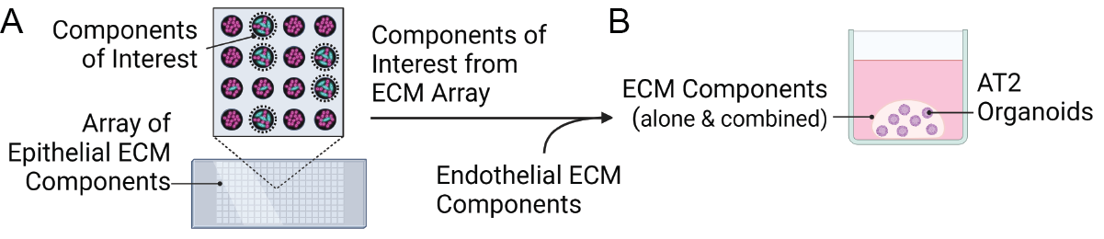**Figure 6:** **Experiment plan for Aim 2.** **a)** ECM array to identify epithelial-associated ECM proteins of interest. **b)** Embedding AT2 organoids in baseline epithelial ECM combination and endothelial-associated ECM proteins. Created with BioRender.com.

***2.1 Epithelial-associated ECM Array:*** To efficiently identify a baseline combination of relevant epithelial-associated ECM proteins, I will utilize an ECM array from Advanced BioMatrix. The array contains nine ECM proteins typically found in epithelial basement membrane (collagen I, collagen III, collagen IV, collagen V, collagen VI, fibronectin, laminin, vitronectin, and tropoelastin) in 36 different combinations (and nine replicates of each combination) printed onto the hydrogel-coated surface of a slide. I will seed the dual reporter AT2 cells in the array and capture fluorescence imaging timepoints at 12, 24, and 48 hours to assess changes in AT1 reporter expression and cell morphology. After 48 hours, I will fix the cells and use IF to stain for AT2 cell, transitional cell, proliferation, and cell stress markers.

***2.2 Epithelial- and Endothelial-associated ECM Organoid Culture:*** To determine the effect of endothelial-associated ECM proteins on epithelial cell fate, I will culture dual reporter iPSC-derived AT2 organoids in baseline epithelial-associated ECM proteins with the addition of endothelial-associated ECM proteins. I will utilize the combinations of interest identified by the array in ***2.1*** as a baseline composition of ECM and add endothelial-associated basement membrane components. Additionally, AT2 organoids will be cultured in each component alone and in Matrigel as controls. To account for differences in gel stiffness between each condition, which can also influence AT1 differentiation [9,39] I will use atomic force microscopy to measure the elastic modulus as a measure of stiffness for each. To capture temporal information regarding changes in epithelial identity upon culture in each ECM condition I will perform live fluorescence confocal microscopy of the NKX2.1-GFP and RAGE-tdTomato reporters at 6-, 12-, 24-, 48-, 72-, 96-, and 120-hour timepoints. After 5 days of culture, I will collect the organoids for the same experimental measures described in ***1.1***, with the addition of fibrotic and inflammatory markers to validate if the effects are mimicking a healthy or disease state.

**Expected Outcomes:** ***2.1:*** I expect the most relevant conditions from the ECM array to include collagen I, collagen IV, collagen VI, laminin, and tropoelastin, determined by IF for protein expression showing mature AT2 markers, lack of transitional cell markers, expression of proliferative markers, and absence of cell stress markers, as well as possibly increased AT1 reporter expression and AT1 morphology. I don’t anticipate that collagen III or collagen V will support AT2 maturation and differentiation to AT1, as they are not expressed as highly in alveolar ECM as in other lung regions [38]. I anticipate that fibronectin or vitronectin also will not support AT2 differentiation to AT1, and may even lead to more transitional cells, as they are increased in diseases such as IPF where transitional cells are known to accumulate [2, 29]. ***2.2:*** I expect to see an increase in AT1 reporter expression and thin, elongated morphology that is greatest in the baseline ECM gel with endothelial-associated components added, followed by the baseline ECM gel alone, and lowest in Matrigel. Likewise, I anticipate that the gene expression and protein expression corresponding to AT2 maturity and AT1 identity will increase, to transitional cell state will decrease, and to disease states will decrease or remain unchanged, with the greatest changes to this effect seen in baseline ECM gel with endothelial-associated components added.

**Pitfalls & Alternative Approaches:** ***1)*** The experiments for this aim share the first limitation discussed in Aim 1 and its corresponding solutions. ***2)*** If all conditions in the ECM array in ***2.1*** lead to AT1 reporter expression and/or protein expression of transitional cell markers, it is possible that the ECM protein layer is thin enough that the hard surface of the slide induced differentiation as has been previously described in literature [38]. In this case, I would identify the baseline epithelial ECM composition by simplifying the components from the array to only include collagen I, collagen IV, collagen VI, laminin, and tropoelastin and then culturing dual reporter AT2 organoids in domes of the combinations of those five ECM proteins that would have been included in the two-dimensional ECM array. ***3)*** If the expected outcomes for ***2.1*** are not observed, it is possible that a longer culture period would be required to induce changes in AT2- and AT1-associated protein expression. I would then repeat the experiment for longer durations of 72 and 96 hours. Likewise, if a similar outcome is observed in ***2.2***, I would repeat the experiment for a longer period of 10 and 15 days before considering alternate hypotheses. ***4)*** Given mechanical stressors such as stiffness are reported to induce AT2 differentiation to AT1 and transitional states [9, 39], it is possible that effects of the ECM proteins tested may be obscured by differences in stiffness between conditions. If the expected outcomes occur but increase with gel stiffness rather than in the order expected, I will apply an alternative approach to isolate the effects of protein composition from those of gel stiffness. To do so, I will obtain assistance from a biomaterials lab we have existing collaborations with and use their hyaluronic acid-based gels with tunable elastic moduli to create gels containing each ECM protein combination with equivalent stiffness [40]. This approach is feasible but would likely result in a delay to the projected research project timeline.

**Biological Variables, Rigor, and Reproducibility:** The experiments outlined in this proposal will primarily utilize knock-in dual fluorescent reporter iPSC-derived alveolar organoids [33]. This line has been thoroughly characterized and validated by the Center for Regenerative Medicine at Boston University and will be confirmed again by our laboratory prior to the proposed research activity. For rigorous analyses, each replicate (n=1) will consist of roughly 100 pooled organoids. AT2 differentiation from the iPSC stage will be completed at least three separate times so that each experiment can be repeated a total of at least three times from independent batches of iPSC-derived AT2. For the co-culture experiments, RVEC cell lines derived from multiple human donors will be provided by the Rafii Lab at Weill Cornell Medicine and used for independent experiments [32]. These have already been characterized and validated but will be confirmed again by our laboratory. Statistical analyses will be performed for variables following a normal distribution using student’s t-test or ANOVA for more than two independent groups. Mann-Whitney U test will be used for variables that do not follow a normal distribution. A p-value of less than 0.05 will be the threshold for statistical significance, and data will be represented by mean and standard deviation. Sex as a biological variable: For the RVECs, cell lines from both XX and XY genetic backgrounds will be included in the studies. For the dual reporter iPSC-derived AT2, only one cell line has been established, which is from an XY genetic background. No sex-dependent trends are anticipated, but if they do arise, sample sizes will be adjusted to appropriately to perform sex-based *post hoc* data analyses.

**Timeline:** I anticipate that the proposed research plan will take approximately two years to complete, following the timeline shown in Figure 7.

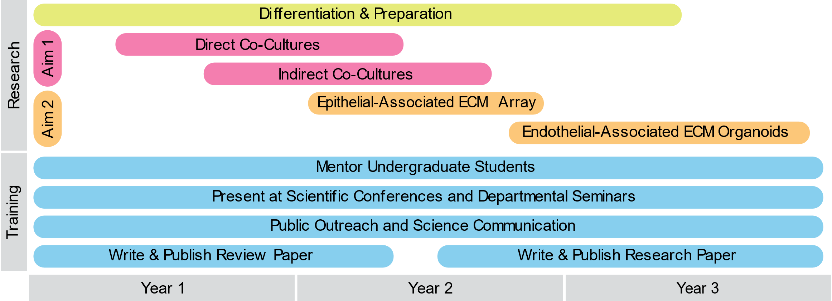

**Figure 7: Timeline for proposed research plan.**

**Future Directions:** The research outlined in this proposal will identify sources of cues leading AT2 cells to differentiate to AT1. Future follow-up experiments will then address specific signaling pathways that these cues act through. *Building upon* ***Aim 1***: If my results show increased AT2 maturity and AT1 markers in the distanced co-culture experiments, I will perform follow-up proteomics analyses of the cell culture media to identify potential secreted factors that may be responsible. If I only observe these changes in direct co-culture, I will perform single-cell RNA sequencing (scRNAseq) to identify potential interactions and compare to primary human pediatric and adult datasets generated by my lab. *Building upon* ***Aim 2***: If the expected outcomes are observed for both Aim 1 and Aim 2, follow up experiments would include additional co-culture of endothelial cells and AT2 in the ECM gel established in Aim 2 to determine if both factors together may have a synergistic effect on AT2 to AT1 differentiation, or if endothelial cells themselves are producing some of the ECM proteins that encourage changes in epithelial cell fate. If the expected outcomes are not observed in Aim 2, the same follow-up co-culture experiments would be warranted, but with the aim of determining if perhaps endothelial-associated ECM components only support but are not sufficient to invoke AT2 differentiation to AT1. For greater temporal characterization of specific signaling events leading to differentiation of AT2 to AT1, developing an iPSC cell line with dual reporters for an AT2-specific marker and AT1-specific marker would be a logical future goal. Such an endeavor was not included in this research plan due to the existence of an alternative dual reporter iPSC line suitable for the purposes of these aims.

Future directions within the field that will build upon this work will include development of a more representative model of the alveoli to study disease mechanisms and develop new therapeutics. The cues elucidated by this research will also enable development of new targeted therapeutics to treat lung diseases that involve impaired development or regeneration.

**References:**

1. Sun, X. *et al.* A census of the lung: CellCards from LungMAP. *Dev. Cell* **57**, 112-145.e2 (2022).Randis, T. M.
2. Jiang, P. *et al.* Ineffectual AEC2-to-AEC1 Differentiation in IPF: Persistence of KRT8hi Transitional State. *Am. J. Respir. Crit. Care Med.* **0**, 1443–1447 (2019).
3. Kobayashi, Y. *et al.* Persistence of a regeneration-associated, transitional alveolar epithelial cell state in pulmonary fibrosis. *Nat. Cell Biol.* **22**, 934–946 (2020).
4. Strunz, M. *et al.* Alveolar regeneration through a Krt8+ transitional stem cell state that persists in human lung fibrosis. *Nat. Commun.* **11**, 3559 (2020).
5. Jakkula, M. *et al.* Inhibition of angiogenesis decreases alveolarization in the developing rat lung. *Am. J. Physiol.-Lung Cell. Mol. Physiol.* **279**, L600–L607 (2000).
6. Olsen, C. E., Isakson, B. E., Seedorf, G. J., Lubman, R. L. & Boitano, S. Extracellular Matrix-Driven Alveolar Epithelial Cell Differentiation In Vitro. *Exp. Lung Res.* **31**, 461–482 (2005).
7. Ito, J. T. *et al.* Extracellular Matrix Component Remodeling in Respiratory Diseases: What Has Been Found in Clinical and Experimental Studies? *Cells* **8**, 342 (2019).
8. Gillich, A. *et al.* Capillary cell-type specialization in the alveolus. *Nature* **586**, 785–789 (2020).
9. Hoffman, E. T. *et al.* Human alveolar hydrogels promote morphological and transcriptional differentiation in iPSC-derived alveolar type 2 epithelial cells. *Sci. Rep.* **13**, 12057 (2023).
10. Complications Associated with Premature Birth. *AMA Journal of Ethics* doi:10.1001/virtualmentor.2008.10.10.cprl1-0810.
11. Mortality and Acute Complications in Preterm Infants - Preterm Birth - NCBI Bookshelf. https://www.ncbi.nlm.nih.gov/books/NBK11385/.
12. Thébaud, B. *et al.* Bronchopulmonary dysplasia. *Nat. Rev. Dis. Prim.* **5**, 78 (2019).
13. Hilgendorff, A. & O’Reilly, M. A. Bronchopulmonary Dysplasia Early Changes Leading to Long-Term Consequences. *Front. Med.* **2**, 2 (2015).
14. Mižíková, I. & Thébaud, B. Perinatal origins of bronchopulmonary dysplasia—deciphering normal and impaired lung development cell by cell. *Mol. Cell. Pediatr.* **10**, 4 (2023).
15. Wilson, M. S. & Wynn, T. A. Pulmonary fibrosis: pathogenesis, etiology and regulation. *Mucosal Immunol.* **2**, 103–121 (2009).
16. Martinez, F. J. *et al.* Idiopathic pulmonary fibrosis. *Nat. Rev. Dis. Prim.* **3**, 17074 (2017).
17. Barnes, P. J. *et al.* Chronic obstructive pulmonary disease. *Nat. Rev. Dis. Prim.* **1**, 15076 (2015).
18. Lin, C.-R., Bahmed, K. & Kosmider, B. Impaired Alveolar Re-Epithelialization in Pulmonary Emphysema. *Cells* **11**, 2055 (2022).
19. Nasri, A. *et al.* Roles of Mesenchymal Cells in the Lung: From Lung Development to Chronic Obstructive Pulmonary Disease. *Cells* **10**, 3467 (2021).
20. Karakioulaki, M., Papakonstantinou, E. & Stolz, D. Extracellular matrix remodelling in COPD. *Eur. Respir. Rev.* **29**, 190124 (2020).
21. Joshi, S. & Kotecha, S. Lung growth and development. *Early Hum. Dev.* **83**, 789–794 (2007).
22. Mammoto, A. & Mammoto, T. Vascular Niche in Lung Alveolar Development, Homeostasis, and Regeneration. *Frontiers Bioeng Biotechnology* **7**, 318 (2019).
23. Ellis, L. V. & Chen, J. A cell-centric view of lung alveologenesis. *Dev. Dyn.* **250**, 482–496 (2021).
24. Kunig, A. M. *et al.* Recombinant human VEGF treatment enhances alveolarization after hyperoxic lung injury in neonatal rats. *Am. J. Physiol.-Lung Cell. Mol. Physiol.* **289**, L529–L535 (2005).
25. Abman, S. H. Bronchopulmonary Dysplasia. “A Vascular Hypothesis.” *Am. J. Respir. Crit. Care Med.* **164**, 1755–1756 (2001).
26. Thébaud, B. & Abman, S. H. Bronchopulmonary Dysplasia. Where Have All the Vessels Gone? Roles of Angiogenic Growth Factors in Chronic Lung Disease. *Am. J. Respir. Crit. Care Med.* **175**, 978–985 (2007).
27. Yanagihara, T. *et al.* Vascular–Parenchymal Cross-Talk Promotes Lung Fibrosis through BMPR2 Signaling. *Am. J. Respir. Crit. Care Med.* **207**, 1498–1514 (2023).
28. Mižíková, I. & Morty, R. E. The Extracellular Matrix in Bronchopulmonary Dysplasia: Target and Source. *Front. Med.* **2**, 91 (2015).
29. Tomos, I. P. *et al.* Extracellular matrix remodeling in idiopathic pulmonary fibrosis. It is the ‘bed’ that counts and not ‘the sleepers.’ *Expert Rev. Respir. Med.* **11**, 299–309 (2017).
30. Sannes, P. L. Structural and Functional Relationships Between Type II Pneumocytes and Components of Extracellular Matrices. *Exp. Lung Res.* **17**, 639–659 (1991).
31. Sucre, J. M. S. *et al.* Alveolar repair following lipopolysaccharide-induced injury requires cell-extracellular matrix interactions. *JCI Insight* **8**, e167211 (2023).
32. Palikuqi, B. *et al.* Adaptable haemodynamic endothelial cells for organogenesis and tumorigenesis. *Nature* **585**, 426–432 (2020).
33. Burgess, C. L. *et al.* Generation of human alveolar epithelial type I cells from pluripotent stem cells. (2023) doi:10.1101/2023.01.19.524655.
34. Jacob, A. *et al.* Derivation of self-renewing lung alveolar epithelial type II cells from human pluripotent stem cells. *Nat. Protoc.* **14**, 3303–3332 (2019).
35. Gonzalez, R. F., Allen, L., Gonzales, L., Ballard, P. L. & Dobbs, L. G. HTII-280, a Biomarker Specific to the Apical Plasma Membrane of Human Lung Alveolar Type II Cells. *J. Histochem. Cytochem.* **58**, 891–901 (2010).
36. Halabi, E. A. *et al.* Dual-Activatable Cell Tracker for Controlled and Prolonged Single-Cell Labeling. *ACS Chem. Biol.* **15**, 1613–1620 (2020).
37. Nicholls, F. J., Liu, J. R. & Modo, M. A Comparison of Exogenous Labels for the Histological Identification of Transplanted Neural Stem Cells. *Cell Transplant.* **26**, 625–645 (2017).
38. Hoffman, E. T. *et al.* Regional and disease specific human lung extracellular matrix composition. *Biomaterials* **293**, 121960 (2023).
39. Li, J. *et al.* The Strength of Mechanical Forces Determines the Differentiation of Alveolar Epithelial Cells. *Dev. Cell* **44**, 297-312.e5 (2018).
40. Plaster, E. M., Eiken, M. K. & Loebel, C. DMTMM-mediated synthesis of norbornene-modified hyaluronic acid polymers to probe cell-hydrogel interactions. *Carbohydr. Polym. Technol. Appl.* **6**, 100360 (2023).